EVALUATING A HYPOTHESIS:

Once we have done some trouble shooting for errors in our predictions by:

1.Getting more training examples

2.Trying smaller sets of features

3.Trying additional features

4.Trying polynomial features

5.Increasing or decreasing λ

We can move on to evaluate our new hypothesis.

A hypothesis may have a low error for the training examples but still be inaccurate (because of overfitting). Thus, to evaluate a hypothesis, given a dataset of training examples, we can split up the data into two sets: a training set and a test set. Typically, the training set consists of 70 % of your data and the test set is the remaining 30 %.

The new procedure using these two sets is then:

Learn Θ and minimize Jtrain(Θ) using the training set

Compute the test set error Jtest(Θ)

The test set error: 

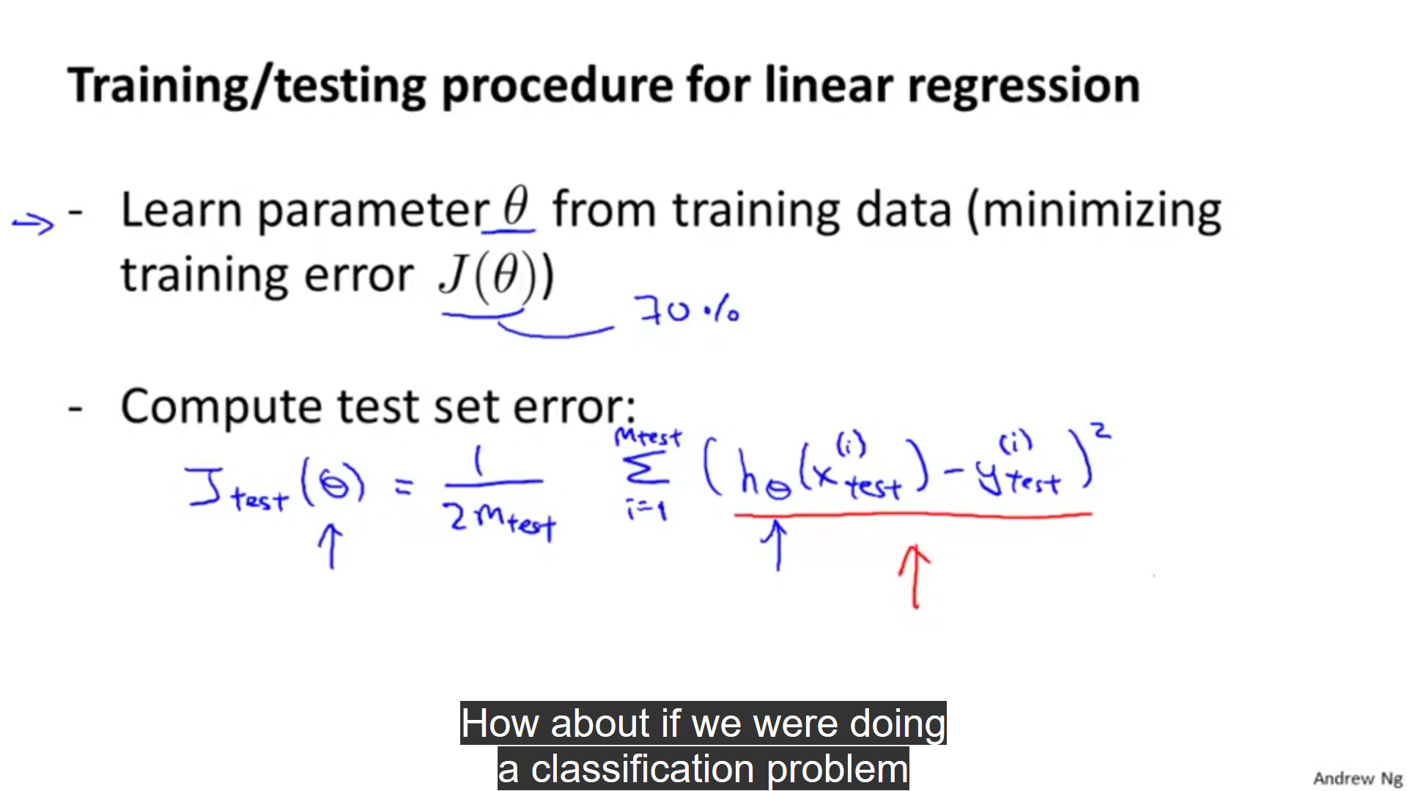

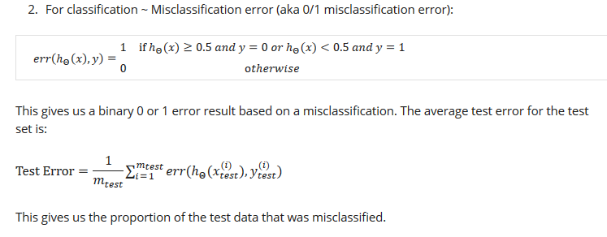

Misclassification error means that our hypothesis classified a value as 0 whereas it was actually 1 and vice versa.

If we have an error, we denote it by 1 and if we don’t , we denote it by 0.

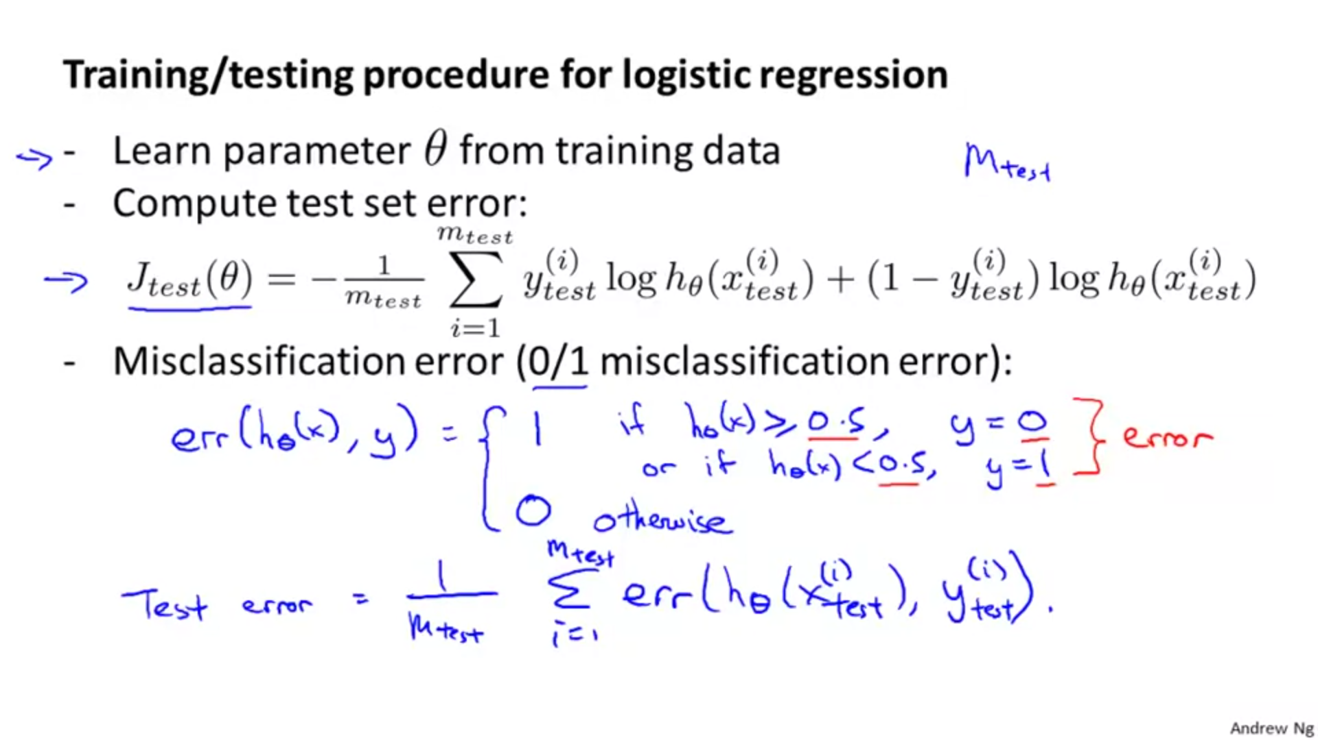

Misclassification error means that our hypothesis classified a value as 0 whereas it was actually 1 and vice versa.

Model selection and train/test/validation sets:

One way to build a model is that take 70% of the datapoints as training examples and 30% of them as test sets.

Now what we do with our training set is that we determine the value of parameters theta0,theta1,…..thetan.

We can use the test set to determine the degree of the equation:

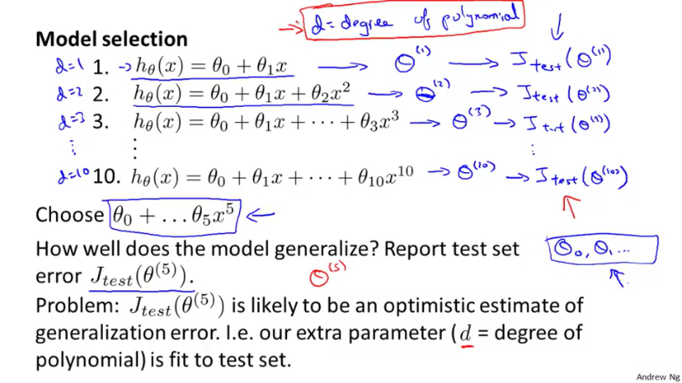

Let us assume that we get the least error in the test set when we take a degree 5 equation.

During this process , unknowingly we do overfitting and fit the model according to the test set. Hence , this model may not work on new data sets so accurately.

Solution of this problem:

We can divide our data into training set, validation set and testing set:

1.We determine theta values using the training set.

2. We determine the degree of the equation using validation set.

3.We test the accuracy and check for overfitting using the test set.

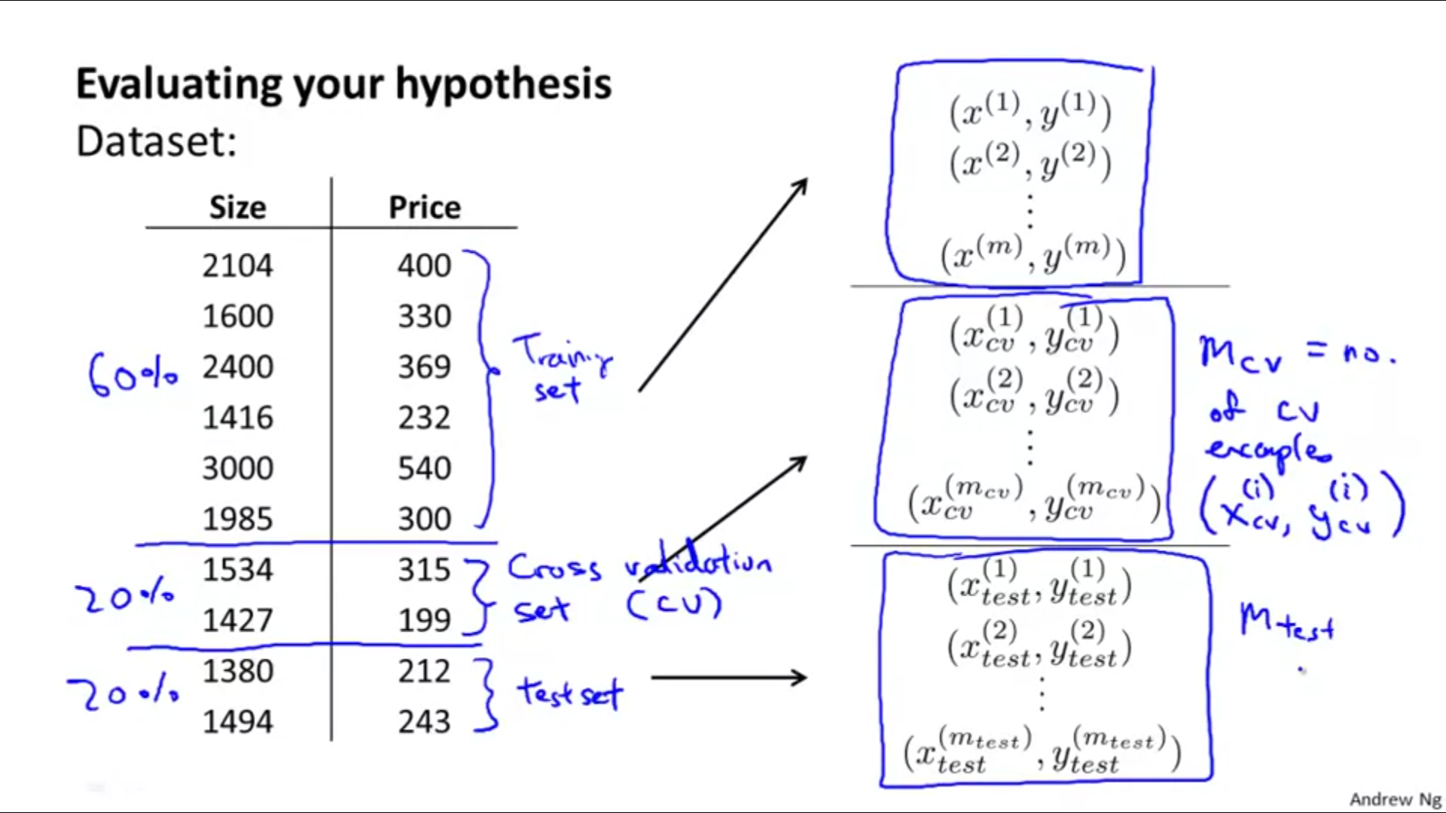

QUESTION:

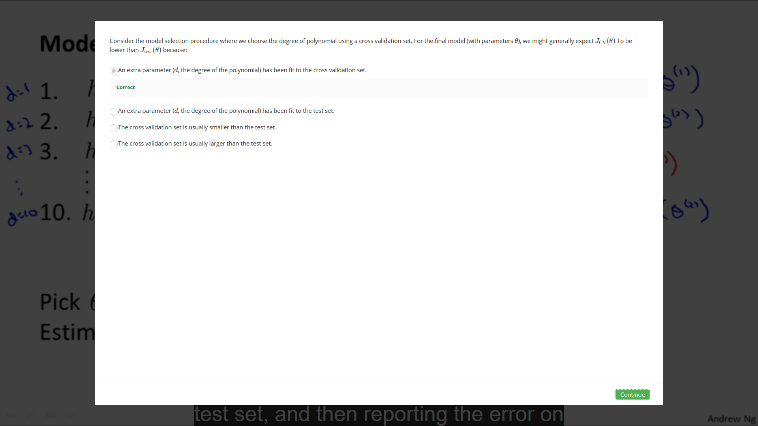

Above question means that we fit our model on the basis of the cross-validation dataset and hence we have less error for our cross-validation dataset, this can also be attributed to some degree of overfitting. Hence, we have more error in our test set compared to the cross-validation set.

Coursera notes:

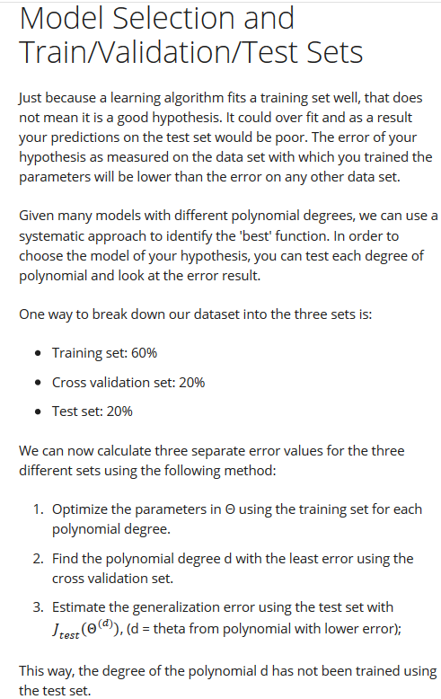

Diagnosing Bias vs. Variance

Now, our model may have high bias(underfitting) or high variance(overfitting).

To solve this problem we make a plot: 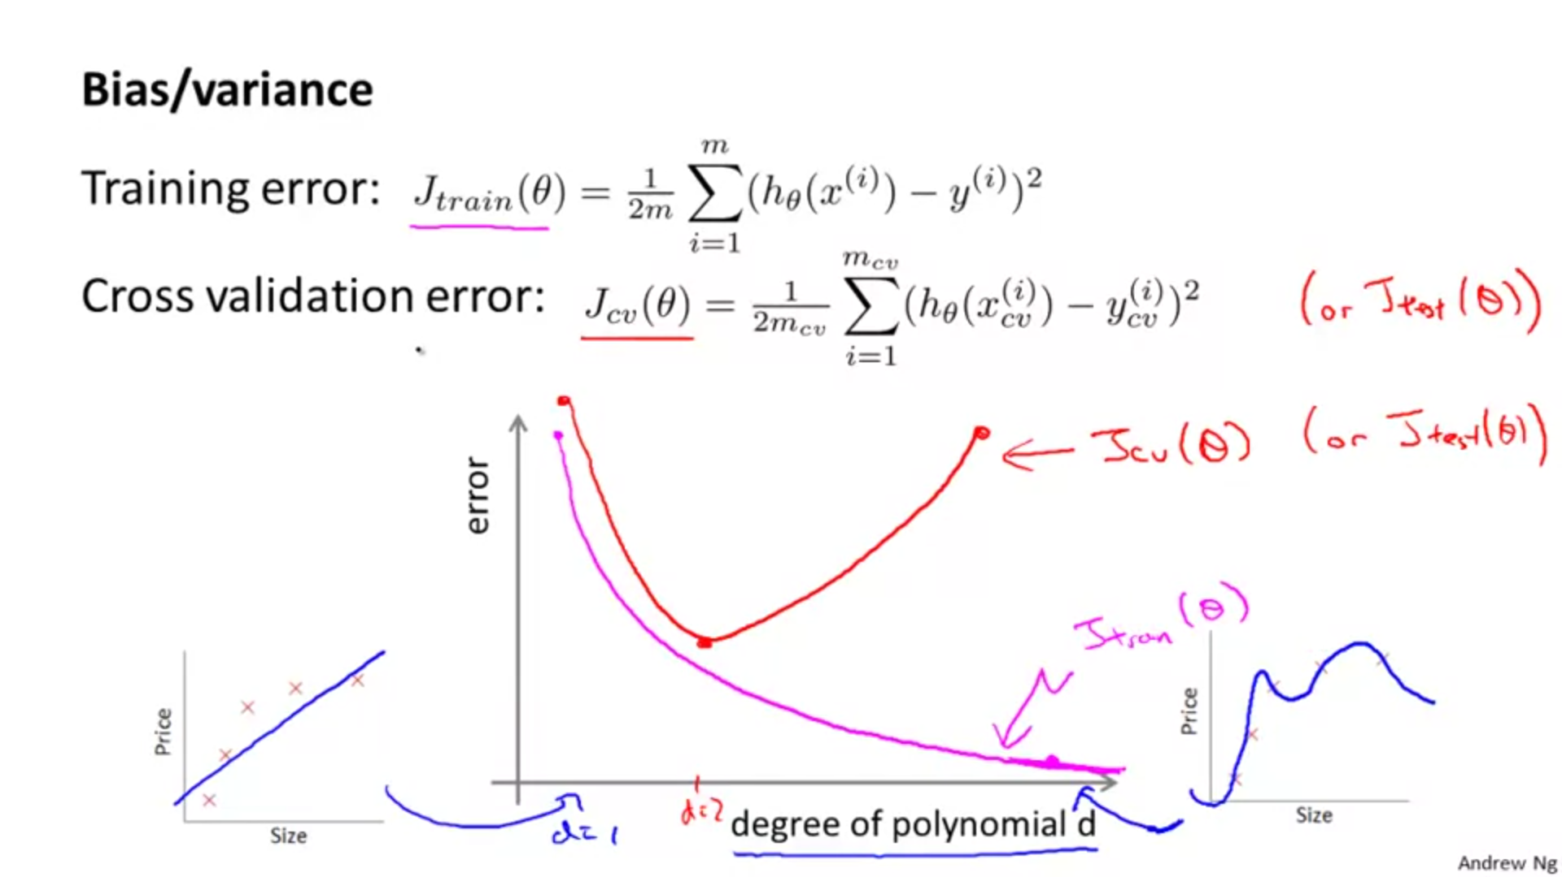

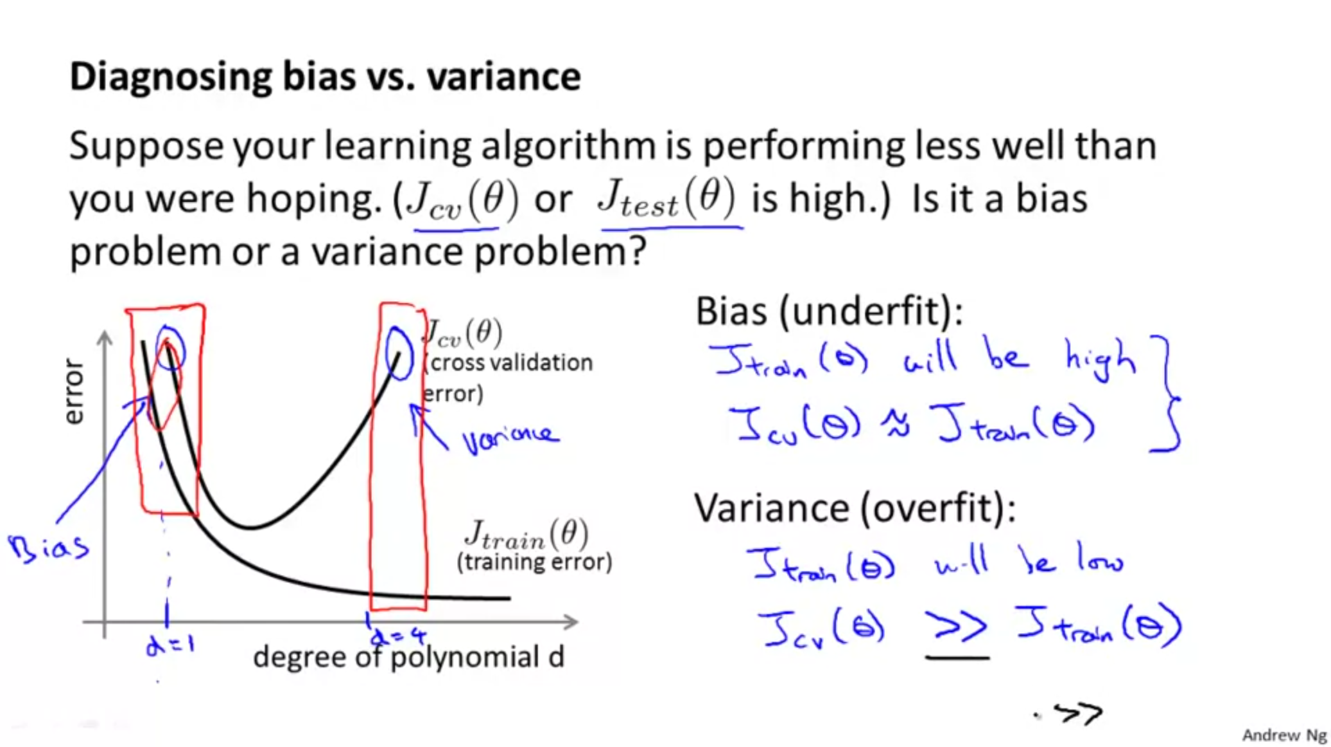

1.When we have bias due to underfitting, it is seen that the error for a given degree is almost the same for training and cross validation dataset.

2. When we have bias due to overfitting, it is seen that the error for a given degree is quite large for cross validation dataset as compared to the training dataset.

Coursera Notes:

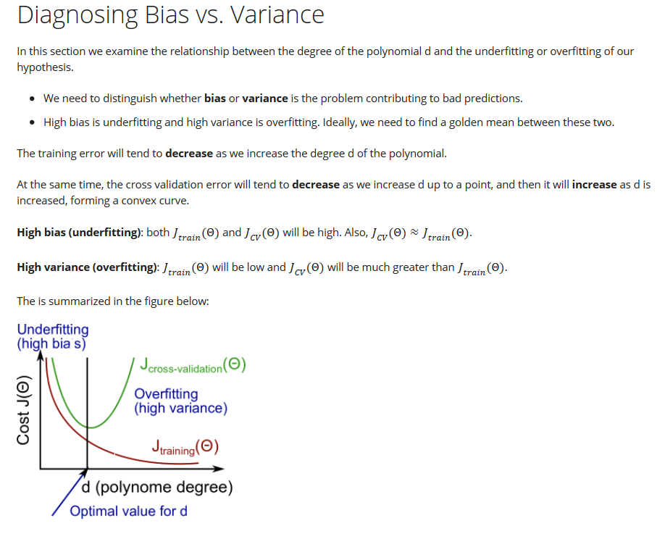

Regularization and bias/variance:

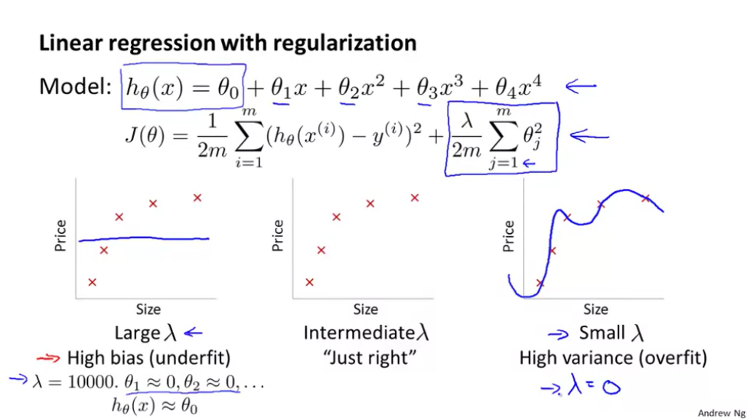

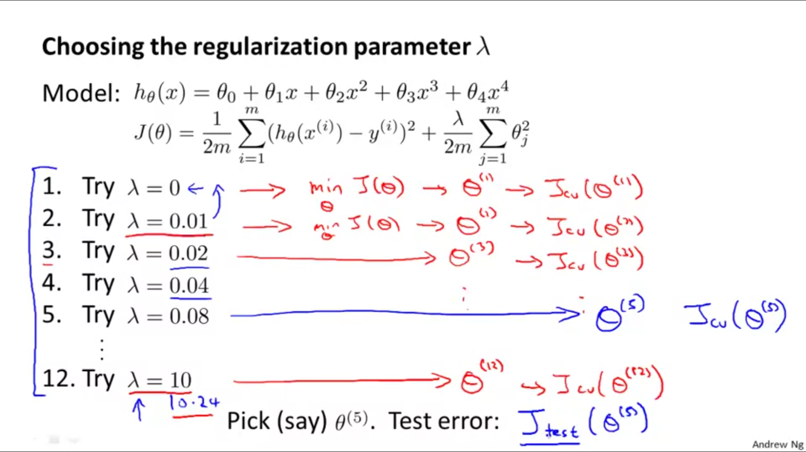

1.We can choose a certain value of lambda and then increase it in multiples of 2 and calculate value of cost function for the cross validation dataset each time.

2.Then we choose the best value of lambda(for which value of cost function is the least ).

3. Then we calculate the cost for the test dataset using this chosen value of lambda.

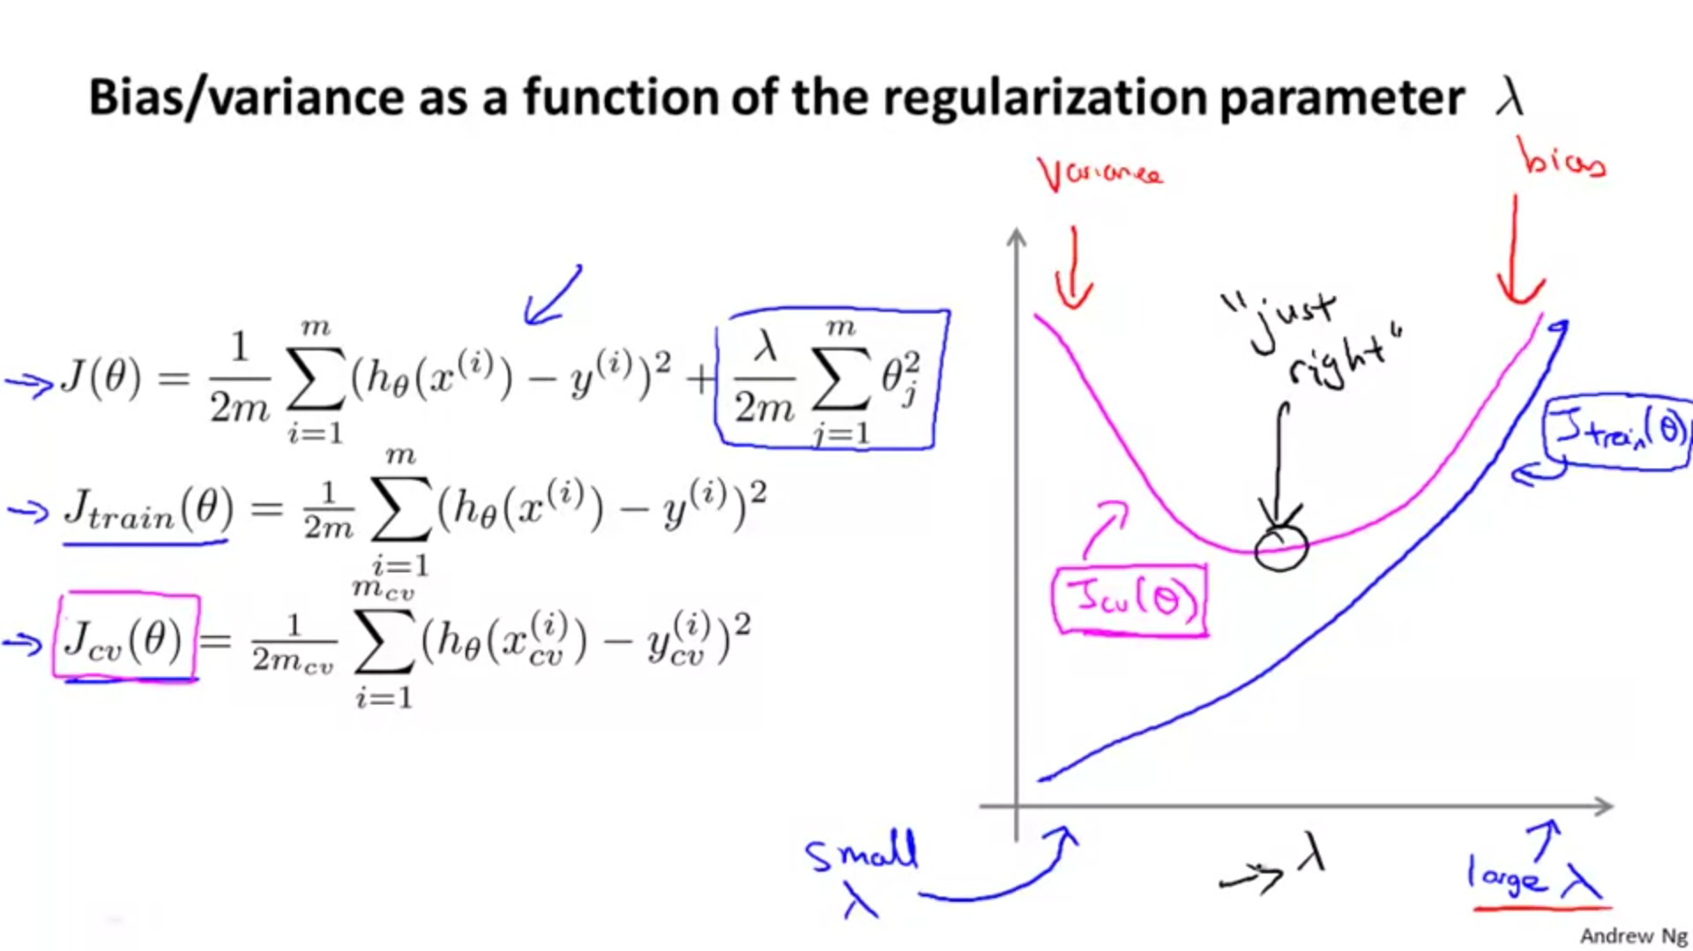

1.Larger values of lambda mean a greater tendency for underfitting(since when lambda is large, theta values get small.)

2. Smaller values of lambda mean a greater tendency for overfitting(since when lambda is small, theta values get significantly large.)

QUESTION:

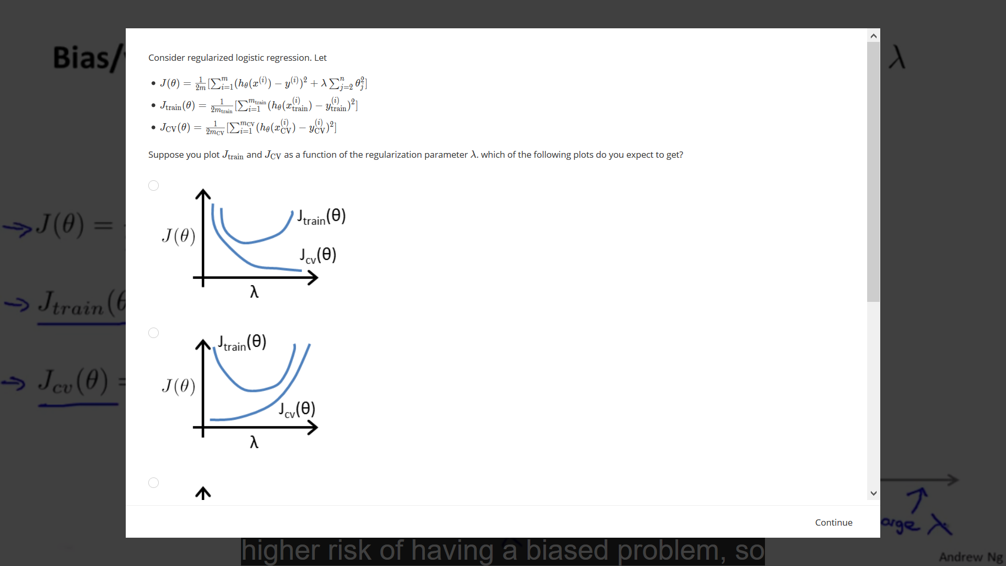

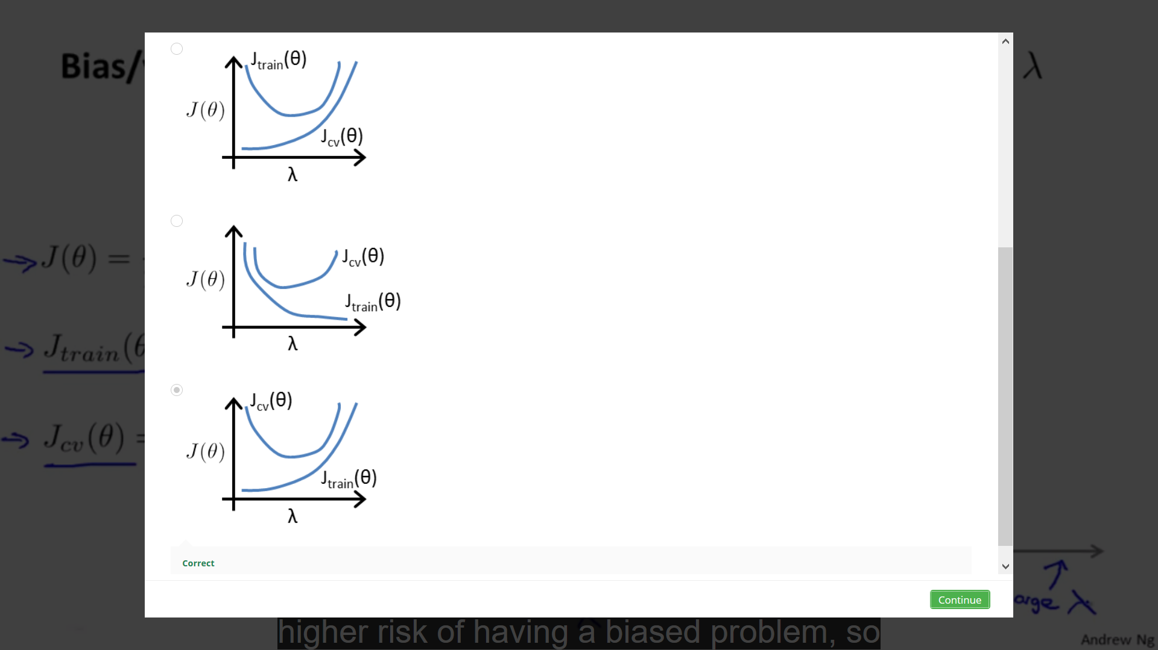

**Coursera notes:**

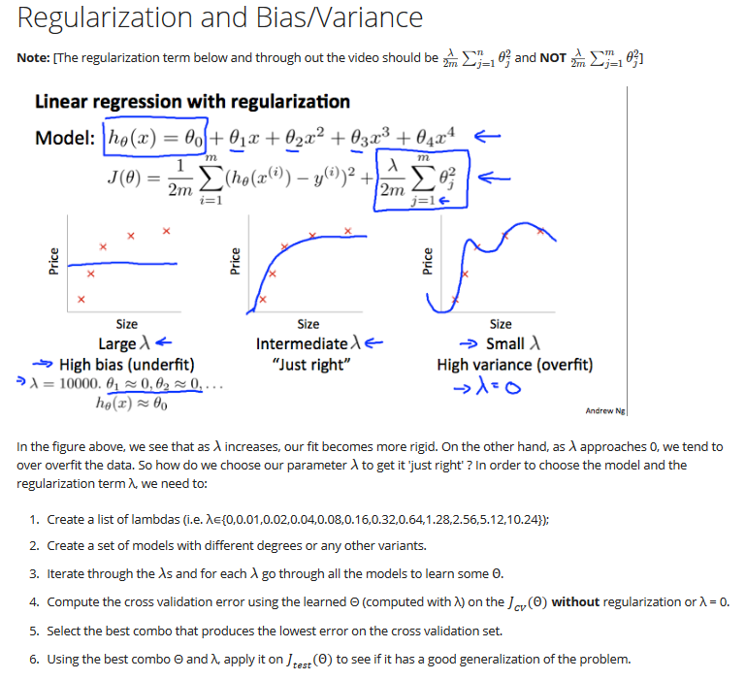

**Learning Curves:**

Learning curves give us the relationship between training set size and the error given by the cost function.

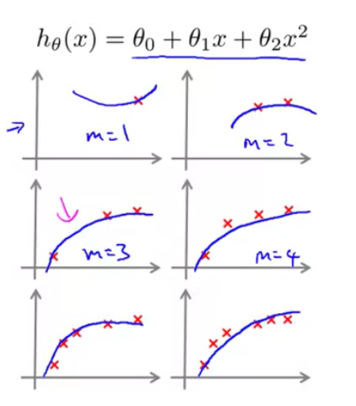

Above image tells us that:

1. When we have only one training example, we can fit a perfectly well quadratic curve.

2.When we have 2, 3 or 4 training examples, even then we can fit a quite well quadratic example.

3.Although as we keep on increasing the number of training examples, the data points don’t fit the curve of quadratic equation very well.

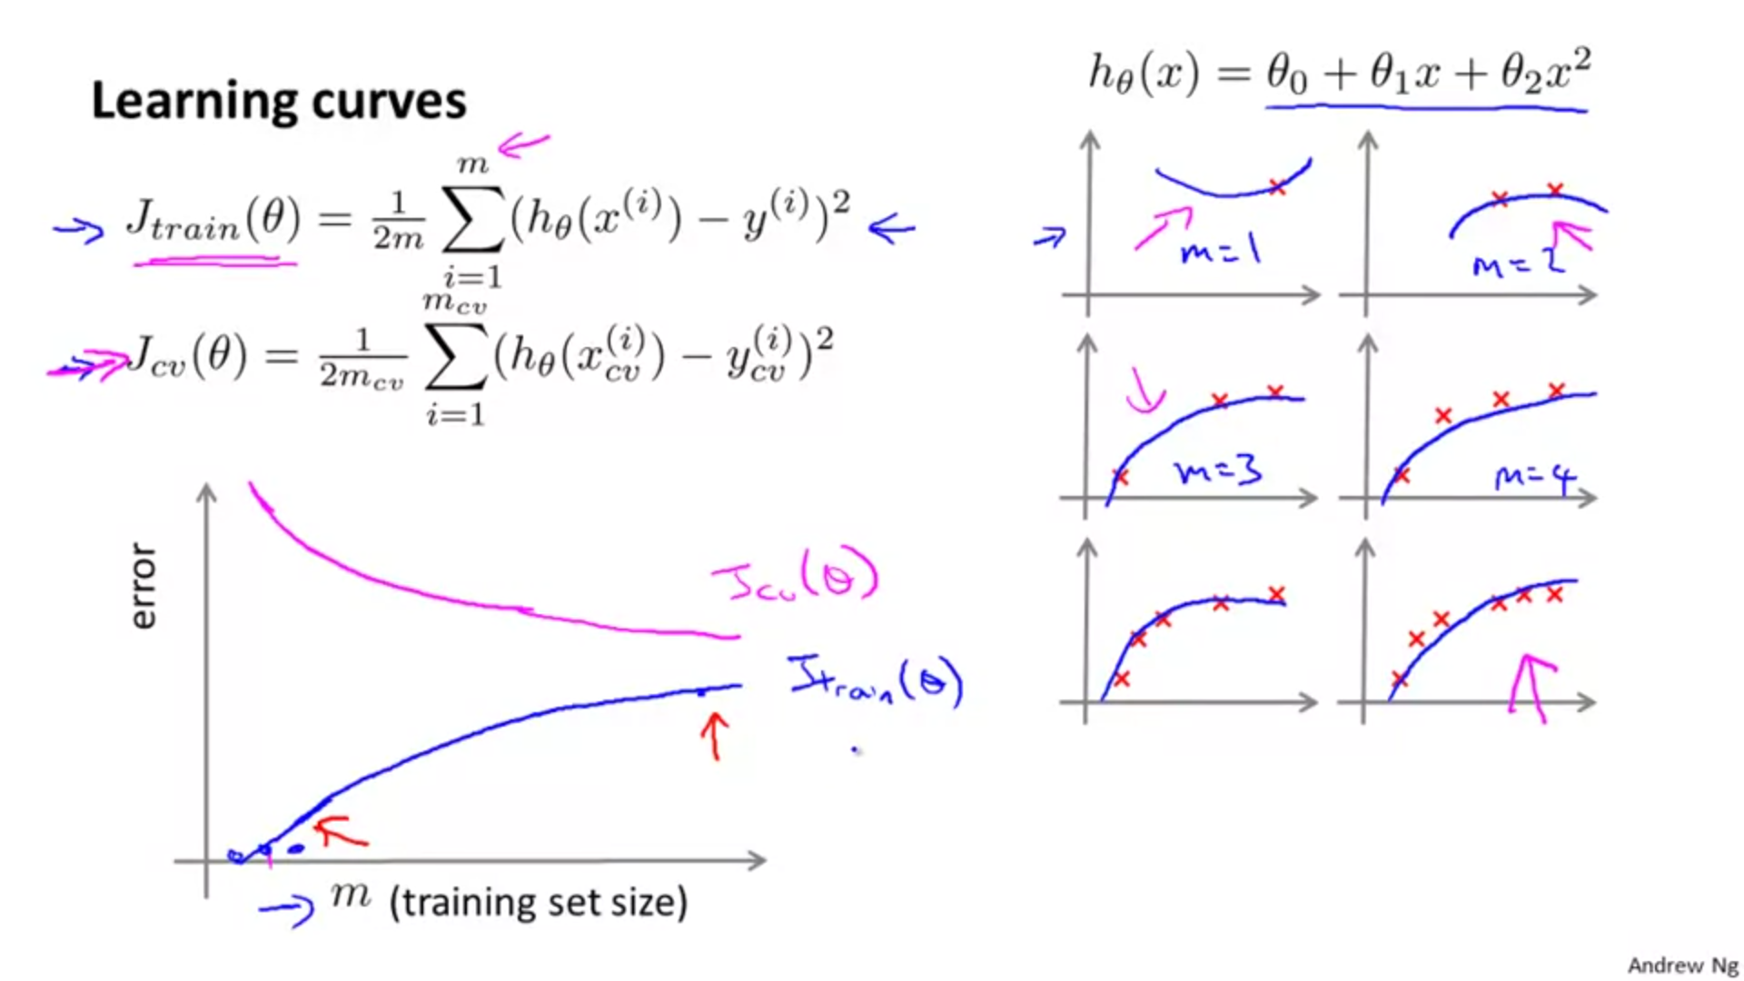

In the above image, we observe:

1.As we keep on increasing the set size, the cross-validation error keeps on decreasing till it a certain point. Although, the opposite is true for training set error.

2.We know that the cross validation is error on the cross validation set that we haven't seen and so, when we have a very small training set, we do not generalize well, just not going to do well on that. So, right, this hypothesis here doesn't look like a good one, and it's only when we get a larger training set that, we get a hypothesis that may fit the data somewhat better. So the cross validation error and the test set error will tend to decrease as the training set size increases because the more data we have, the better we do at generalizing to new examples. So, just the more data we have, the better the hypothesis we can fit. So, if we plot JTrain, and JCV the above graph is the sort of thing that we would get.

3. Hence we conclude cross validation error and test set error will tend to decrease as our training set size increases because the more data we have, the better we do at generalizing to new examples. So, just the more data we have, the better the hypothesis we can fit.

**What the learning curves look like if we have either High Bias or High Variance problems :**

***CASE 1: Suppose the hypothesis has high bias.***

We use an example, of fitting a straight line to data that, you know, can't really be fit well by a straight line.

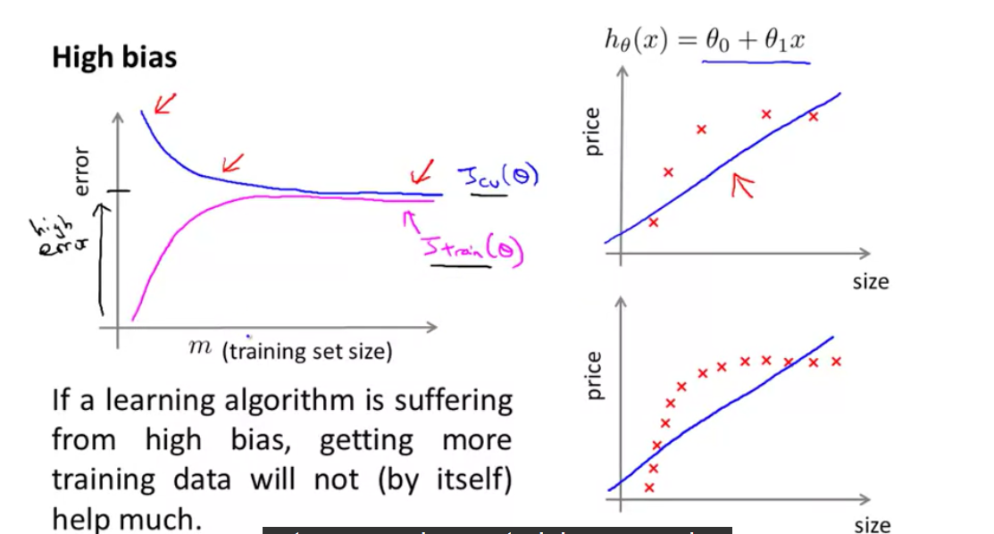

What we infer from the above figure:  
1. On the right side of above figure we see that even as we increase the training set size, our hypothesis more or less remains the same. Hence , the error increases as we increase the training set size because now we are not able to fit more data points properly as compared to when we had less data points.

2.This shows that if we have high bias, increasing our training set size or cross validation set size would not help in decreasing the cross-validation/test set error after a certain amount of set sizes say x (shown in above figure).

***CASE 2: Suppose the hypothesis has high variance.***

We have a case of high variance when , we have a large gap between cross validation set error and training set error:

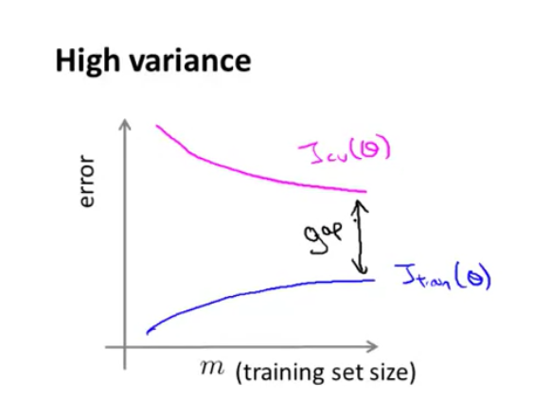

When we extend the JCV(theta) and JTrain(theta) curves further, we observe that as we add more and more data points, the error of cross-validation data points decreases. Hence adding more training/cross-validation sets is beneficial in reducing cross validation error.s

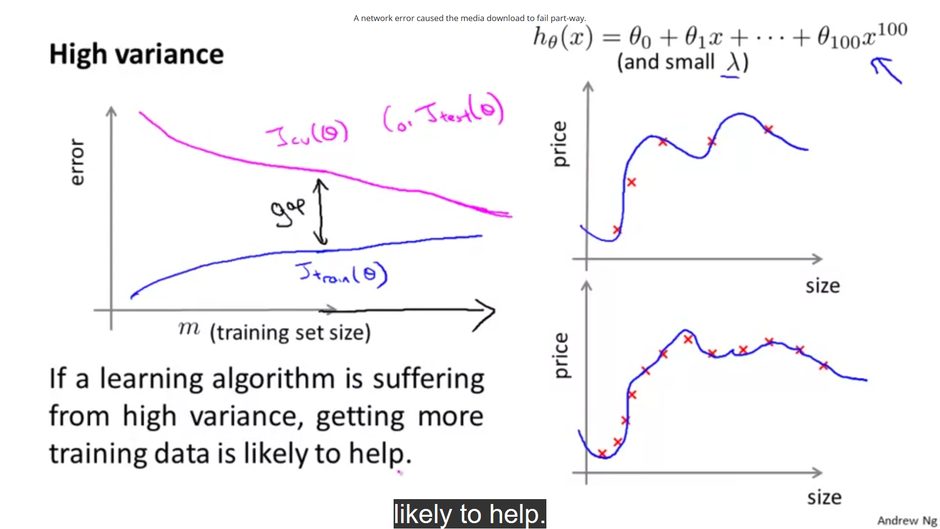

1.On the right side we see that as we keep on adding more and more data points/training sets, we unable to fit the data perfectly well as compared to when we had less training sets.

2.In case of overfitting, we see that as we add more and more data points, the error of cross-validation data points decreases. Hence adding more training/cross-validation sets is beneficial in reducing cross validation error.

**Question:**

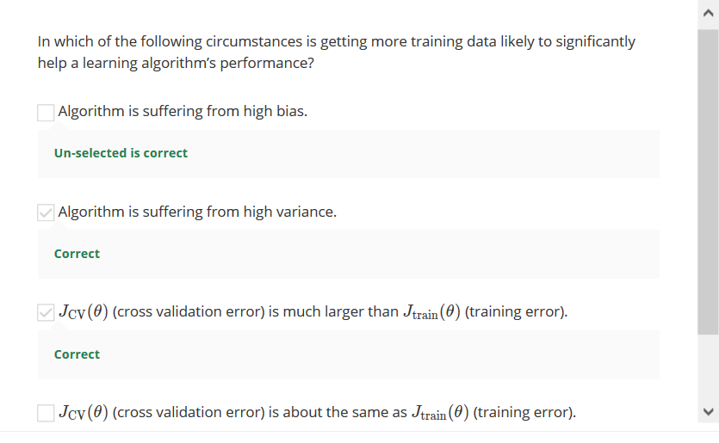



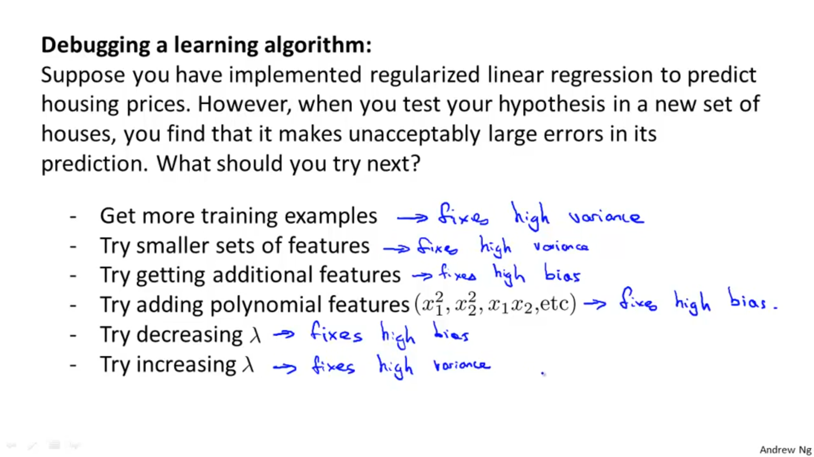

Explaining last two points:

1. Smaller values of lambda lead to overfitting and to solve this problem of overfitting or high variance, we increase the value of lambda.

2. Larger values of lambda lead to underfitting and to solve this problem of underfitting or high bias, we decrease the value of lambda.

*Neural networks and overfitting:*

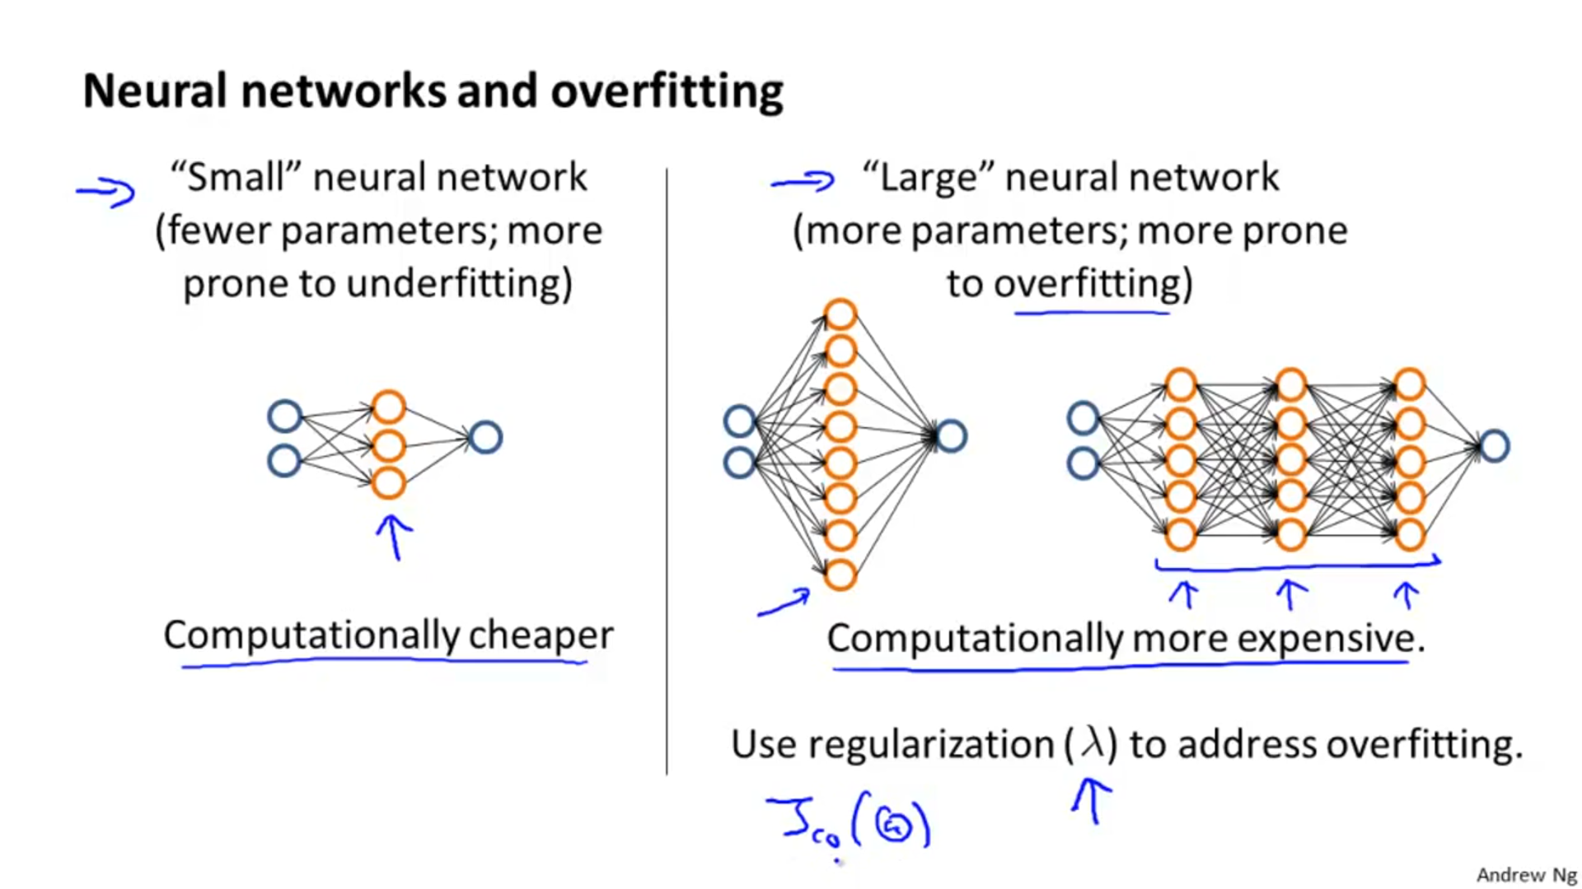

Note: Using a large network with regularisation is often more beneficial than using a small network.

*Question:*

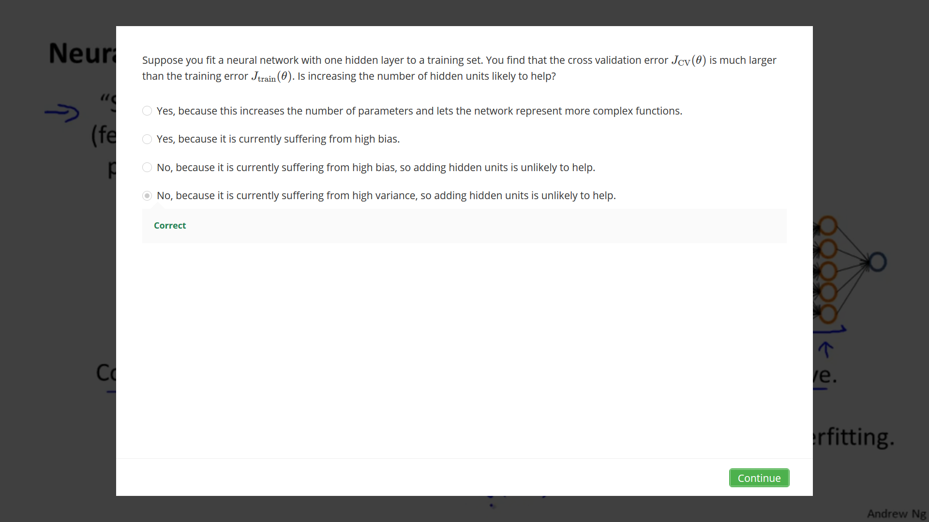

Note: Adding hidden units is not equivalent to adding more training examples. Adding more training examples means adding more rows in the data.

Prioritizing what to work on:

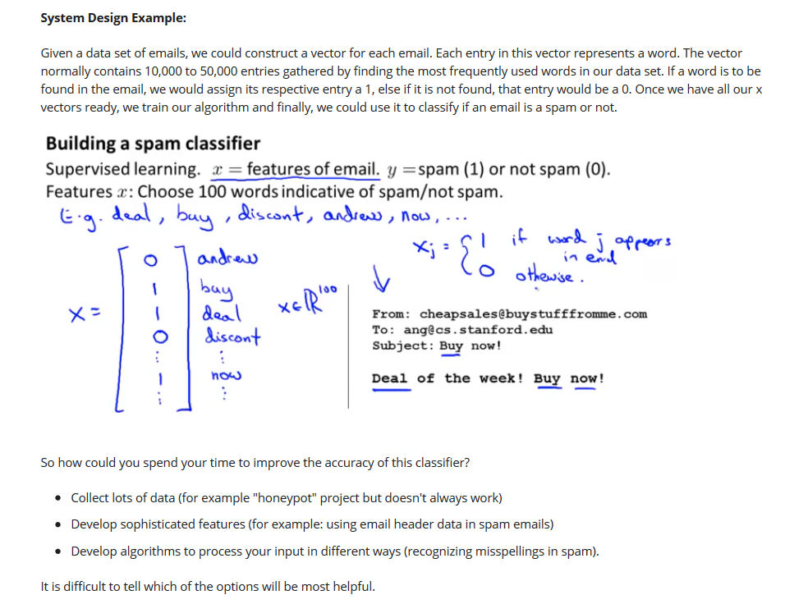Question:



ERROR ANALYSIS:

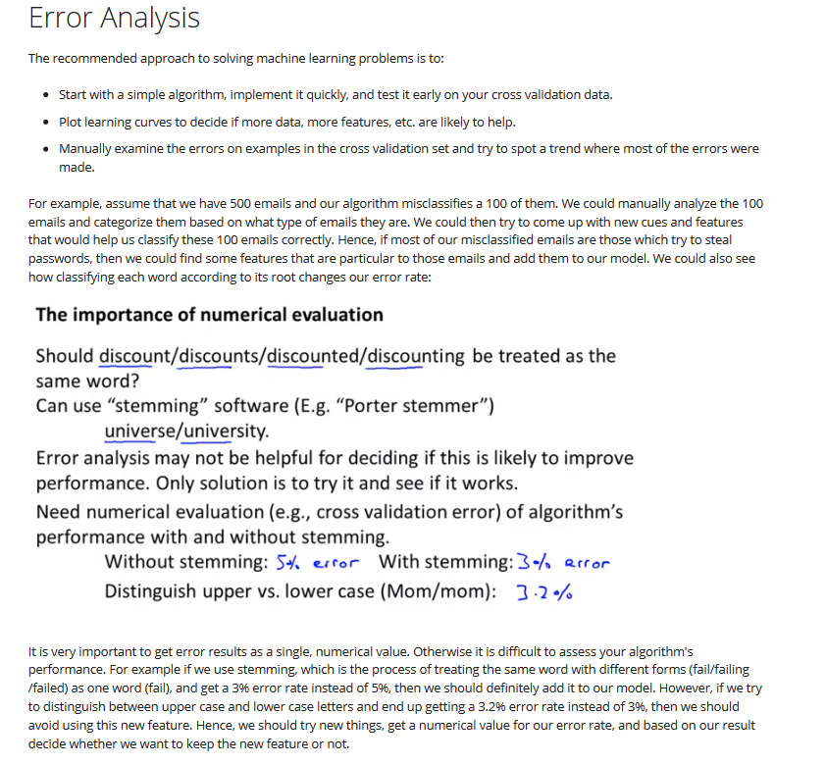

Error metrics for skewed classes:

Skewed class means that we have extreme values in our training set. Say, in a case where we classify cancer vs non cancer patients we only have 0.5% negative cancer cases. This means if we make an algorithm that always predicts negative cancer cases (a value of 0, in case of logistic regression), then we will have 99.5% accuracy.

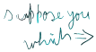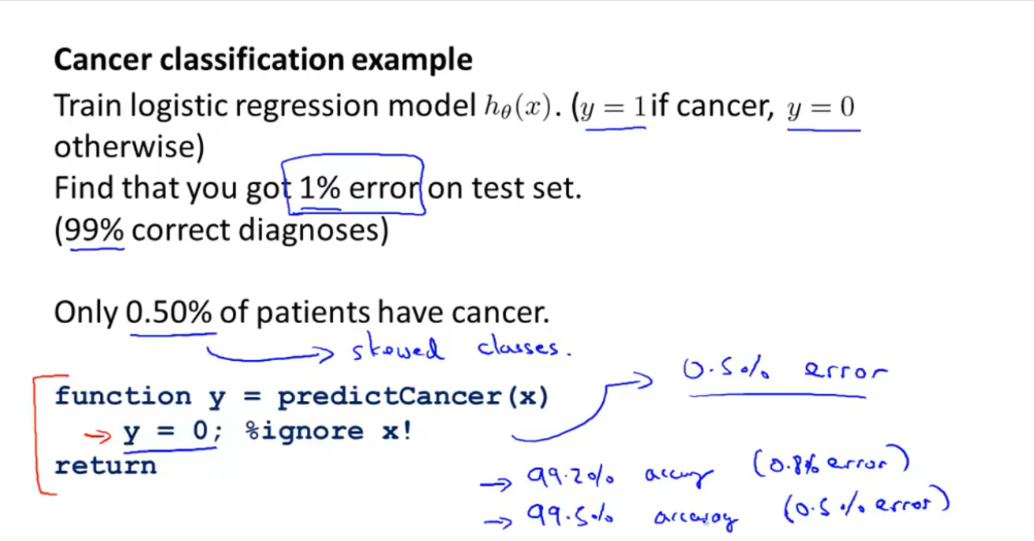

Suppose in another case, we get a training set accuracy of 99.2%. Although when we make an algorithm that always predicts say 0, our accuracy increases to 99.5%. Though the latter algorithm has less error, it is not right to classify everything as 0 just to reduce error rate.

Precision and recall:

To solve above problem, we use the concept of precision and recall:

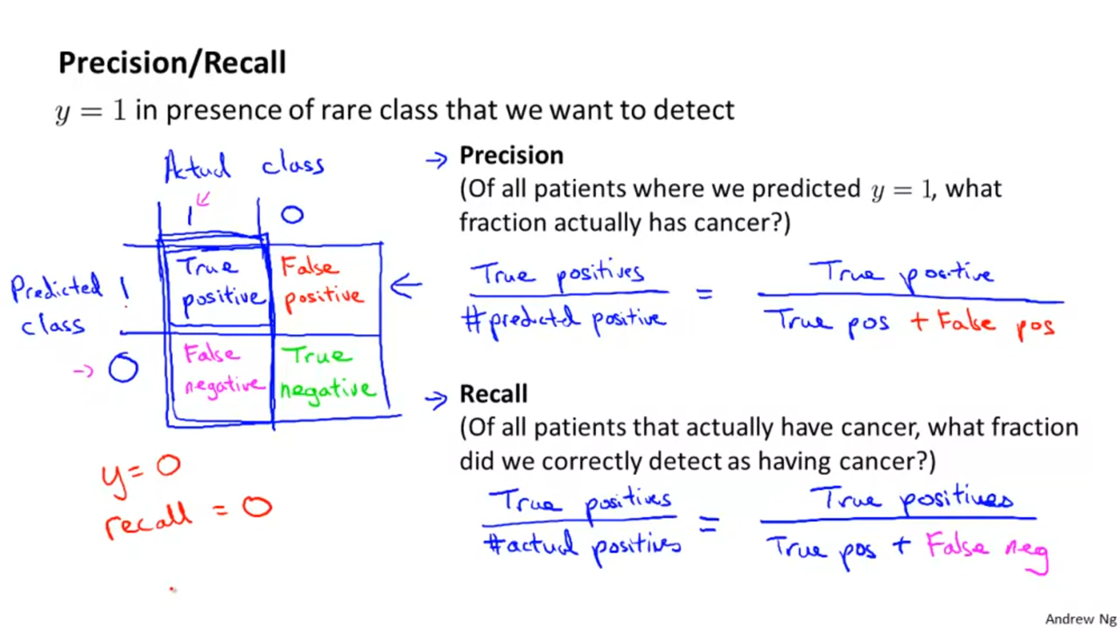

We usually prefer a high value of recall. If we set our predictors to always give y=0, then recall=0 which means our model is not good.

For more information on this topic refer to the topic ‘Key Quantities’ given on page 4 of machine learning basics file.

Trade off between precision and recall:

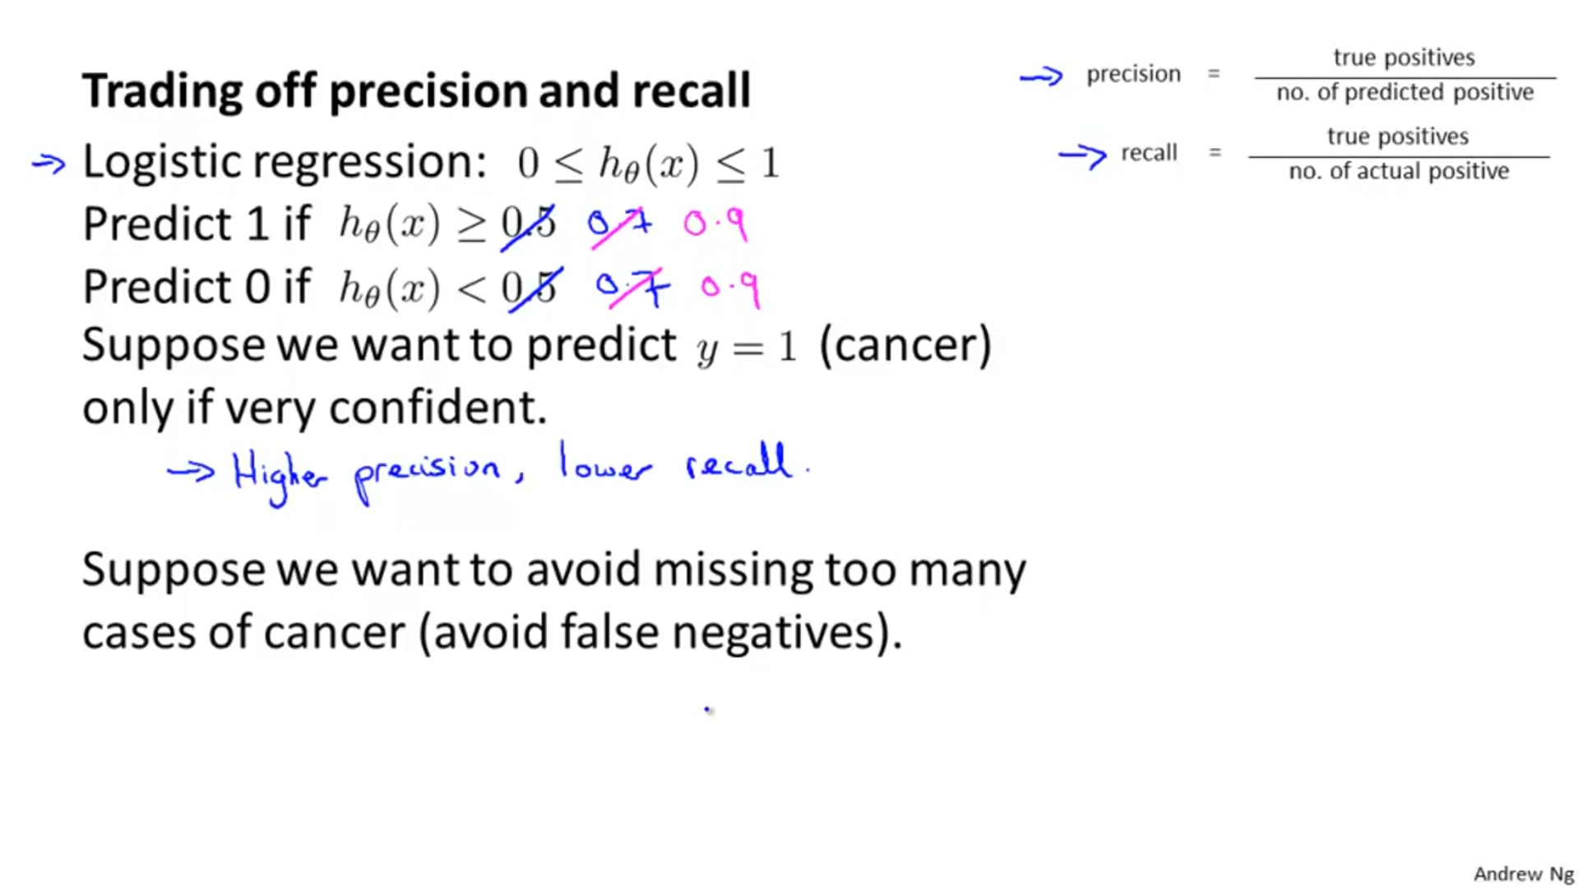If we keep on increasing the threshold parameter, then only few of the cases that come in would be predicted to be positive for cancer. This would increase our precision, since no. of wrong predictions will go down due to ‘stricter’ threshold value say 0.7 and 0.9 instead of 0.5.

Now, suppose we want to avoid false negatives, then what we do is that we increase the recall value .

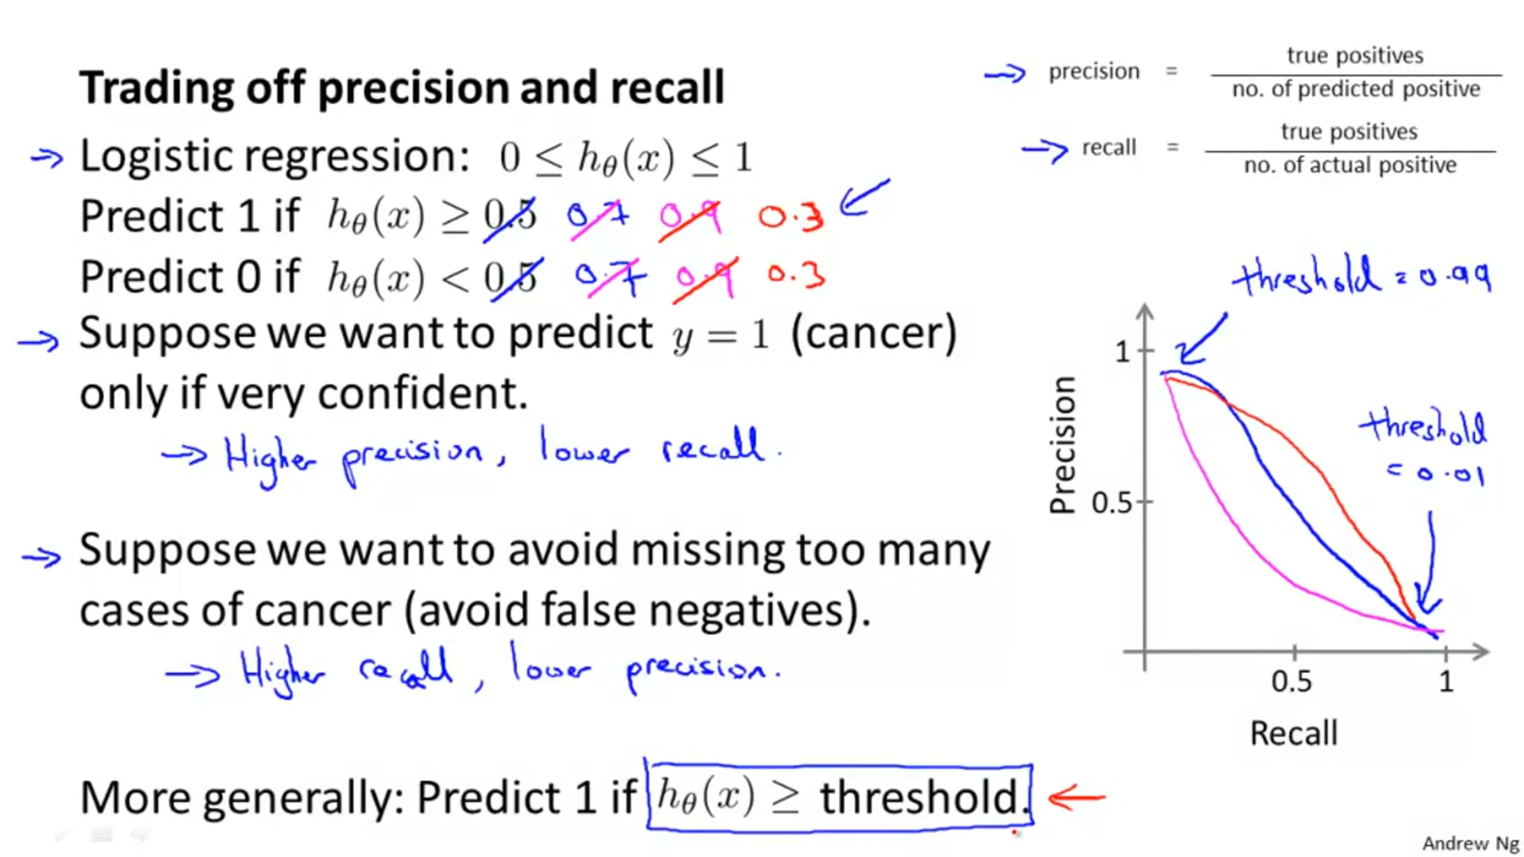

The three coloured lines shown in the graph in the above figure depict the three different relationships that can be there between precision and recall.

COMPARING ALGORITHMS HAVING DIFFERENT VALUES OF PRECISION AND RECALL:

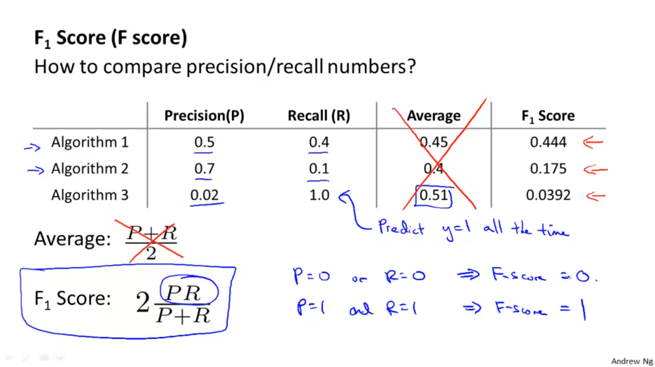

We do not take averages to compare different algorithms because as shown in algorithm 3, if we have skewed classes , then the average can misguide us.

F1 score or F score solves the above inadequacy shown by averages method. This is because when we are calculating F score we take the product of precision and recall. If either of the values are low, the F1 score becomes low.

We say if an algorithm has high value of F1 score, it has a good balance of precision and recall values.

Questions:

